|  |
| --- |
| Frontend Assignment |
| **Module 1) – Foundation** |

**Website**:-

A website is a collection of web pages and related content that is identified by a common domain name and published on at least one web server. Websites are typically dedicated to a particular topic or purpose , such as news , education , commerce ,entertainment or social networking

**Http:-**

Http stands for Hyper Text Transfer Protocol . Is the foundation of the World Wide Web. This is used to load webpages using hypertext link. HTTP is an application layer protocol designed to transfer information between networked devices and runs on top of other layers of the network protocol stack.

**Url:-**

A Uniform Resource Locator(URL).Known as an address on the Web , Is a reference to a resource that specifies its location on computer network had a mechanism for retrieving it.

**Module 2)Fundamentals of IT**

**Domain**:-

In the Internet , a Domain name is a string the identifies a realm of administrative autonomy , authority or control . Domain name are often used to identify services provided through the internet, such as website, email services and more.

**Hosting**:-

 A Web Hosting service is a type of Internet hosting service the hosts websites for clients, i.e. it offers the facilities required for them to create and maintain a site and makes it accessible on the World Wide Web. Companies providing web hosting services are sometimes called web hosts.

SEO**:-**

SEO means Search Engine Optimization and is the process used to optimize a website’s technical configuration, content relevance and link popularity so its pages can become easily findable, more relevant and popular towards user search queries, and as a consequence, search engines rank them better.

# Module 3) HTML

# 

# 

**Q 1} Are the HTML tags and elements the same thing?**

Ans: HTML tags and elements are a lot different. Let’s see what HTML elements and Tags actually are and their differences.

HTML Tags : The starting and ending point parts of an HTML document are HTML tags. Whatever is written inside the angle brackets are known as tags.

Syntax:

<tag>

……

</tagname>

HTML Elements : Elements in HTML that which was between in tags. Which was written in between two tags. Syntax:

<b>This is the content</b>

**Q 2} What are tags and attributes in HTML?**

Ans: HTML Tags : The starting and ending point parts of an HTML document are HTML tags. Whatever is written inside the angle brackets are known as tags.

Syntax:

<tag>

……

</tag>

Attributes in HTML:

Attributes that refers the additional information. Elements and Tags have a Attributes. Example: href

<a href=“ “>Attributes</a>

**Q 3} What are void elements in HTML? With Example.**

Ans: Void elements don’t have a tags. There are no content inside it. This void elements also have a attributes.

Example:-

<br> Tag is used to break a line it move text in next line. <br> is a void element.

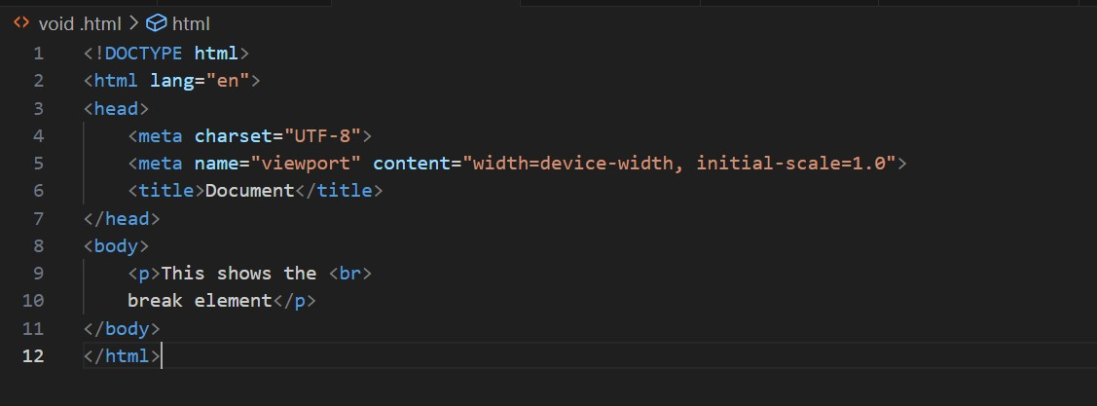

**Q 4} What are HTML Entities? With Example.**

Ans: Entities is used to write special character in HTML. Your keyboard not have some character that time you can use entities. Entities also used to give a space in HTML.

Example:

<!DOCTYPE html>

<html>

<head>

<title>Entities</title>

<body>

<p>Copyright write like this &copy;</p>

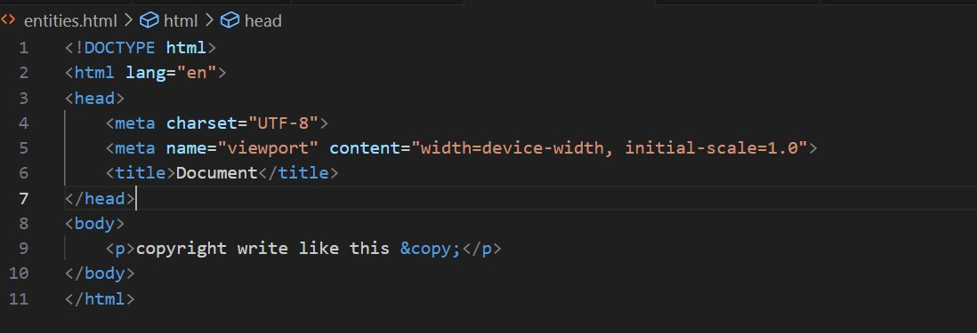 </body> </head>

</html>

Output:

Copyright write like this ©

**Q 5} What are different types of lists in HTML? With Example.**

Ans: HTML have Three main types of lists-

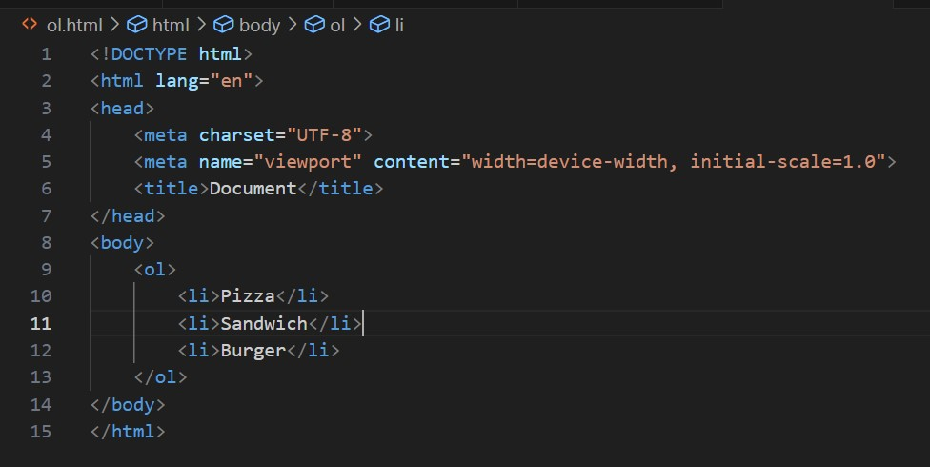

(1)

Ordered List

•Unordered List

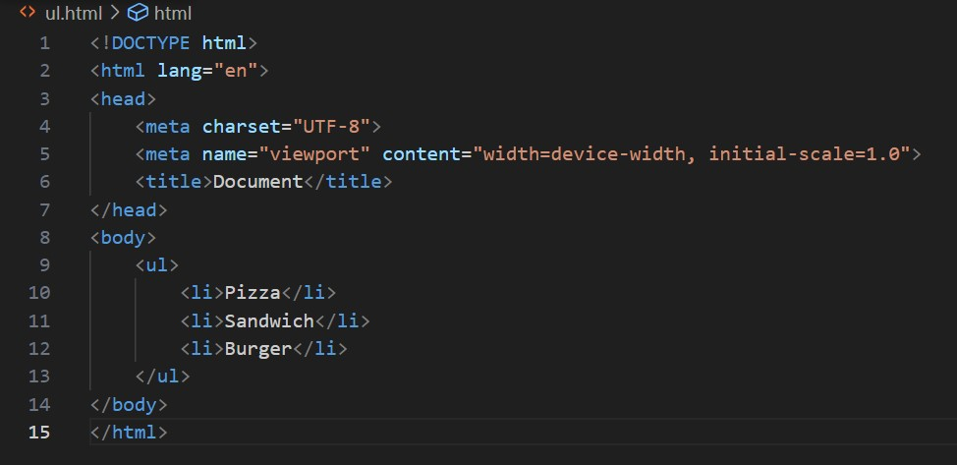

•**Definition List:**

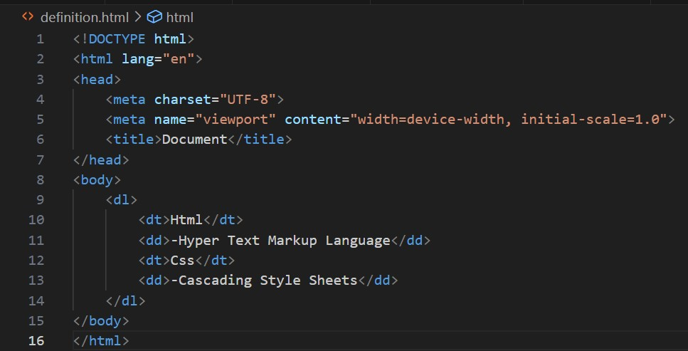

## Q 6}What is the ‘class’ attribute in HTML? With Example

**Ans :-** The class attribute specifies one or more class names for an element.

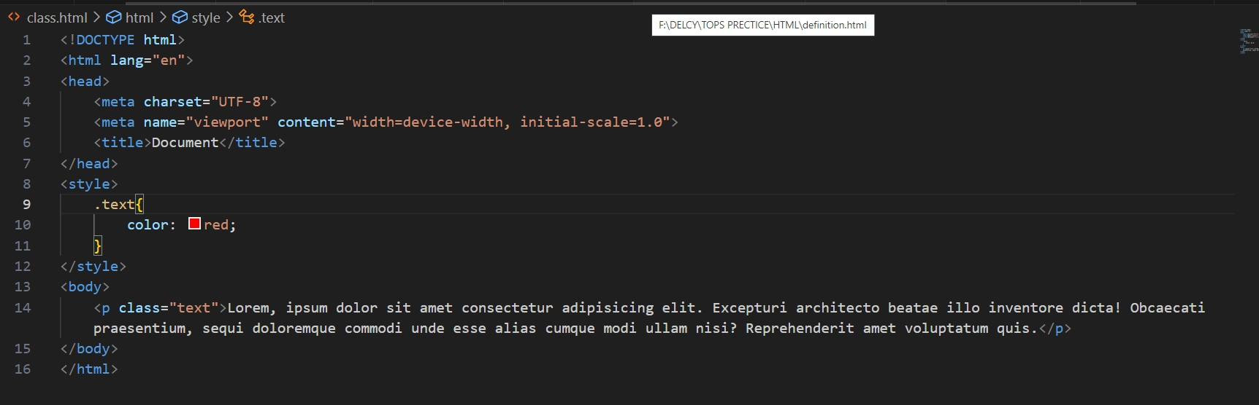

**Q 7}What is the difference between the ‘id’ attribute and the ‘class’ attribute of HTML elements? With Example.** Ans: the difference between Class and ID: A Class name can be used by multiple HTML elements, while an ID name must only be used by one HTML element within the page. Id Attributes

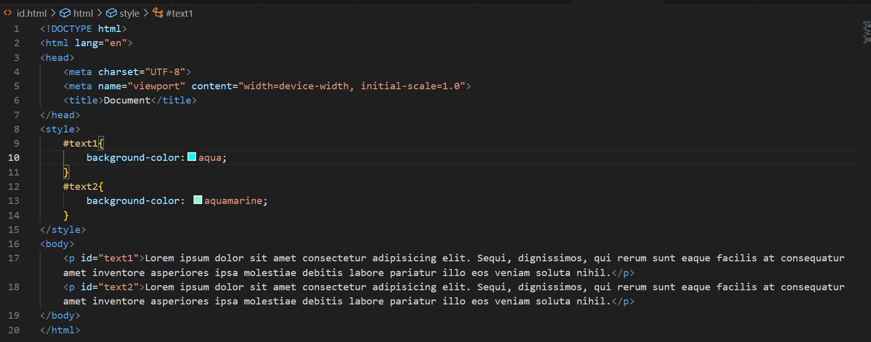

Class Attributes

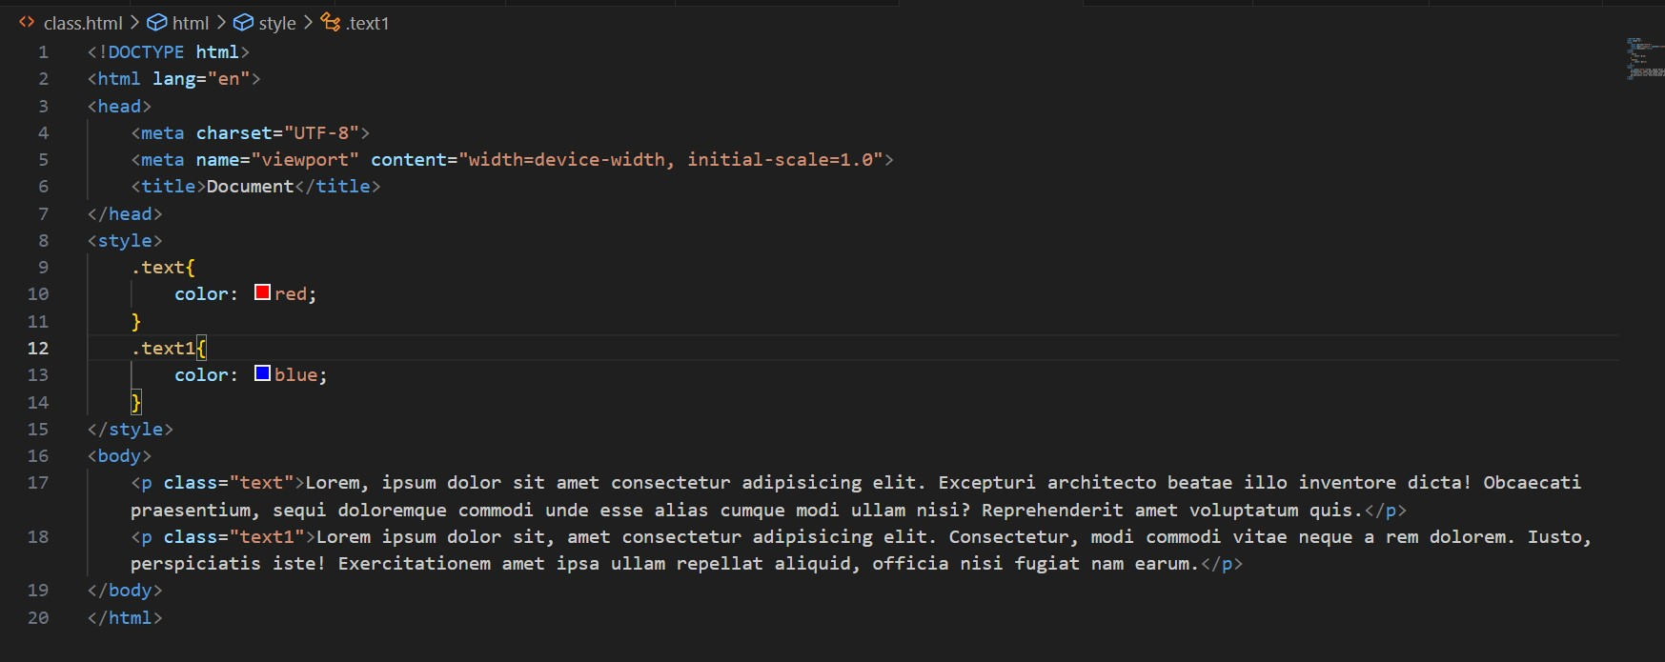

**Q 8} What are the various formatting tags in HTML?**

**Ans :-** Examples of formatting elements include the <b>, <i>, <u>

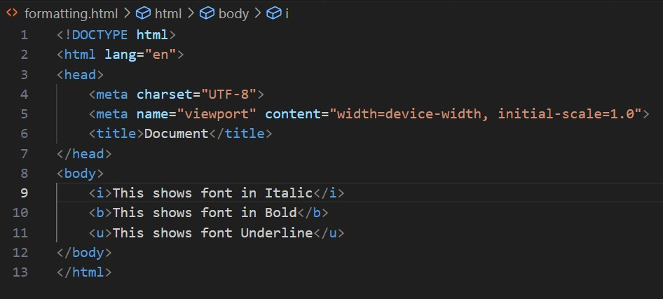



**Q 9} How is Cell Padding different from Cell Spacing? With Example.**

**Ans:** Cell spacing refers to the distance between the cells in a grid layout, and cell padding refers to the space around each cell.  **Cell Padding**

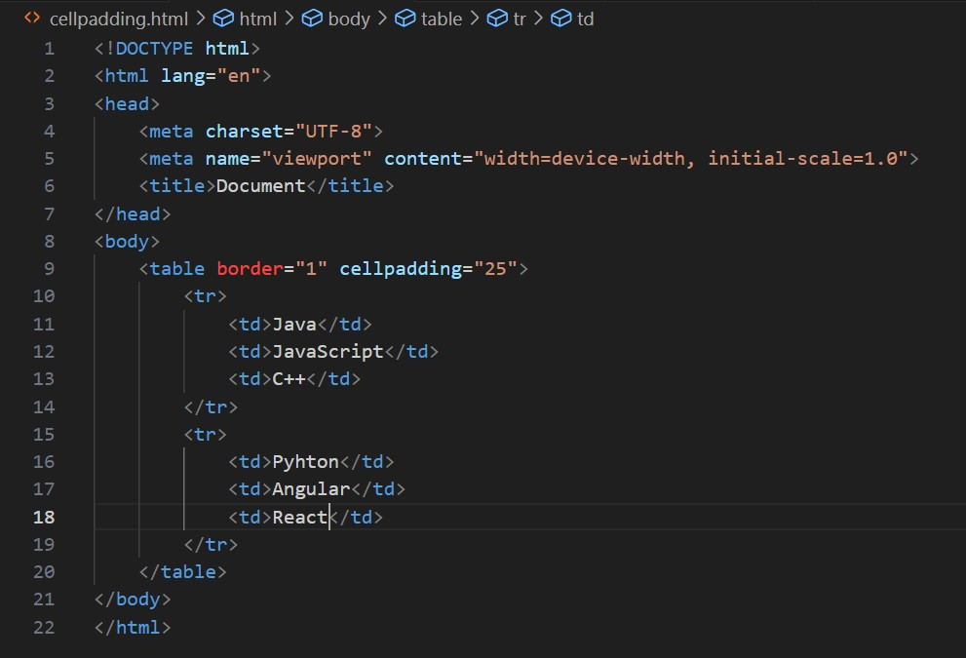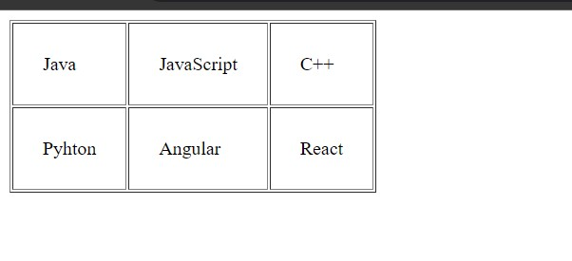

Cell Spacing

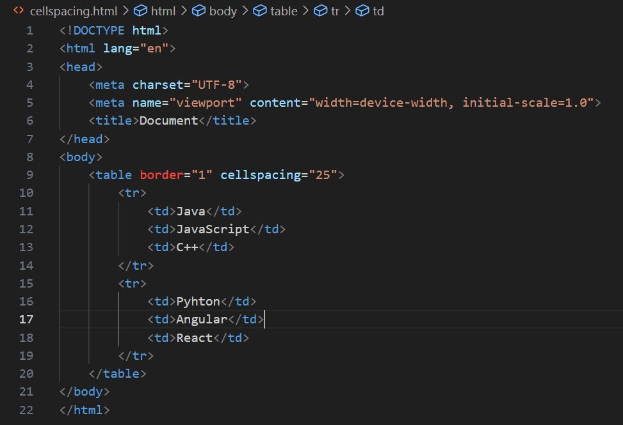

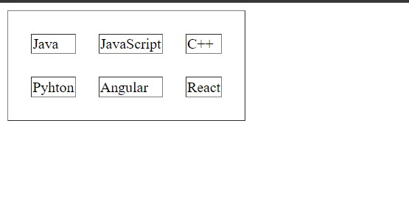

**Q 10}How can we club two or more rows or columns into a single row or column in an HTML table?**

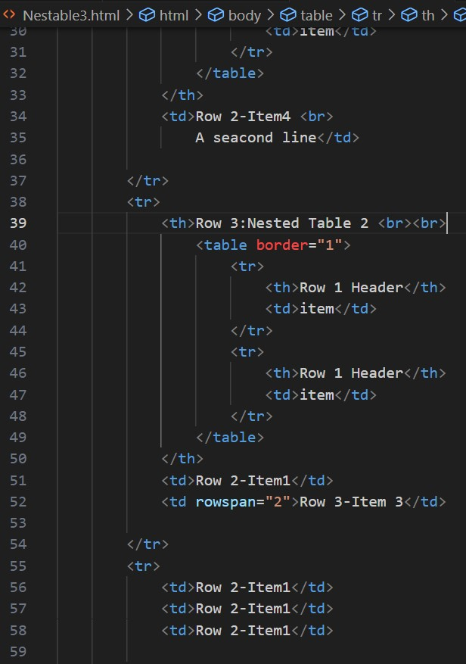**With Example**

**Ans :-** using the rowspan and colspan attribute in HTML. The rowspan is used to merge or combine the number of cells in a row whereas the colspan is used to merge column cells in a table**.**

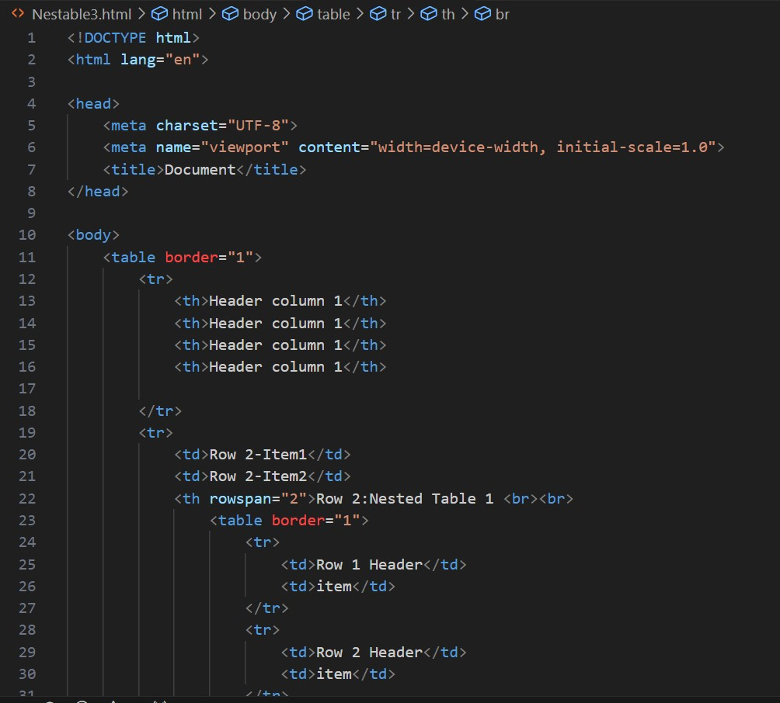

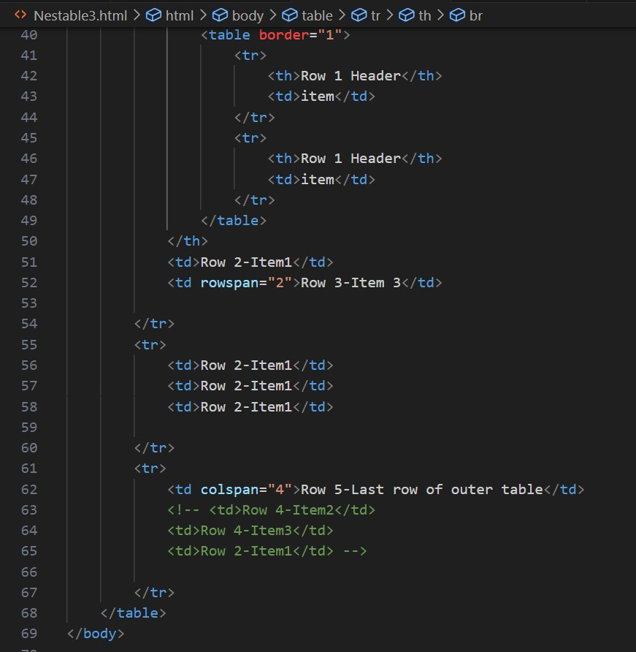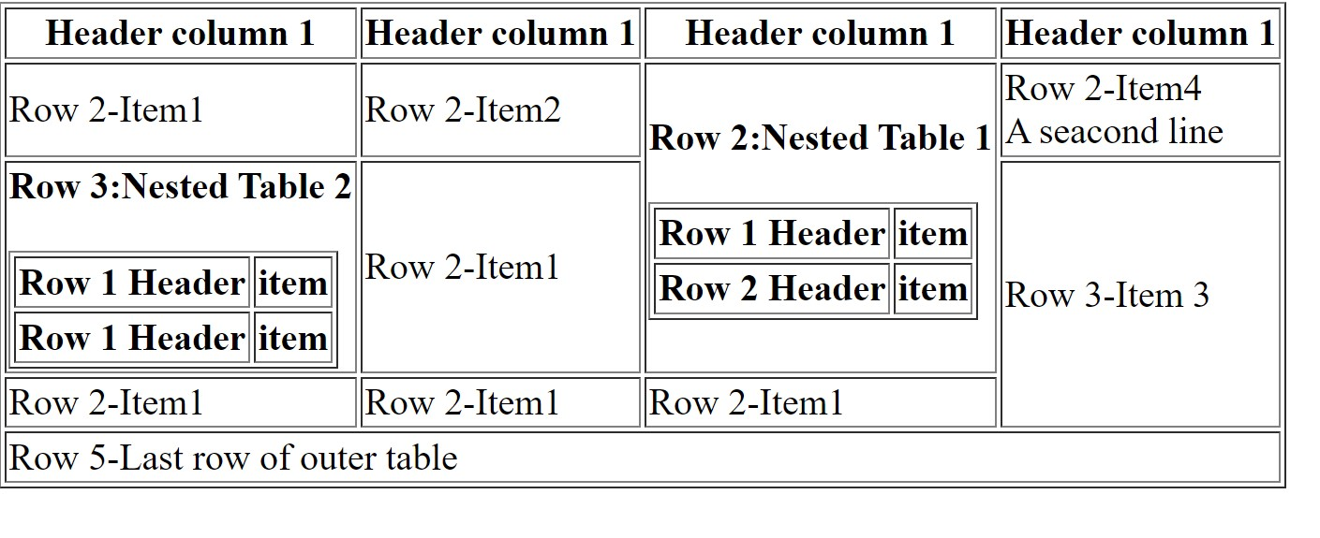

**Q 11}What is the difference between a block-level element and an inline element?**

**Ans :-** Block elements always start from a new line. Inline elements never start from a new line.

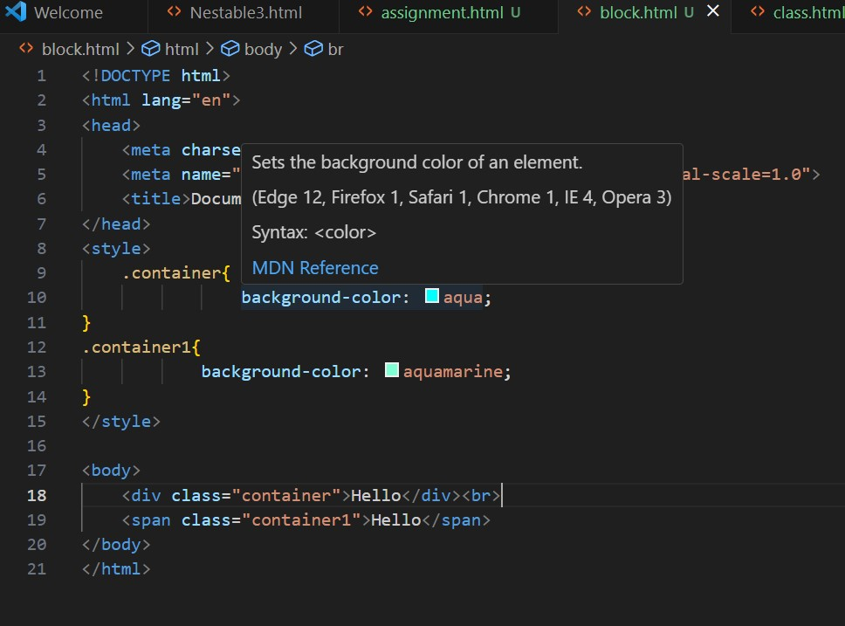

**Q 12} How to create a Hyperlink in HTML? With Example Ans :-** The <a> tag defines a hyperlink**.**

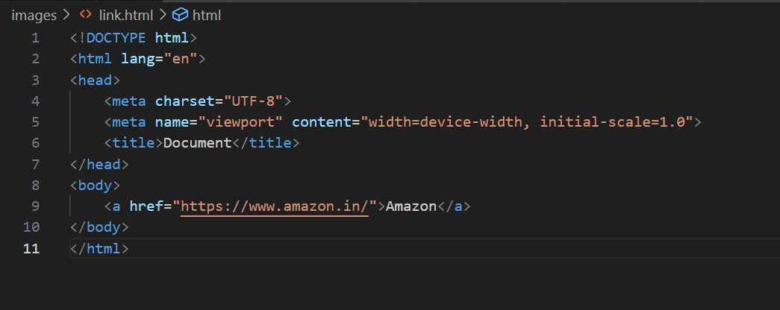



**Q 13}What is the use of an iframe tag? With Example.**

**Ans :-** The <iframe> tag specifies an inline frame. An inline frame is used to embed another document within the current HTML document.

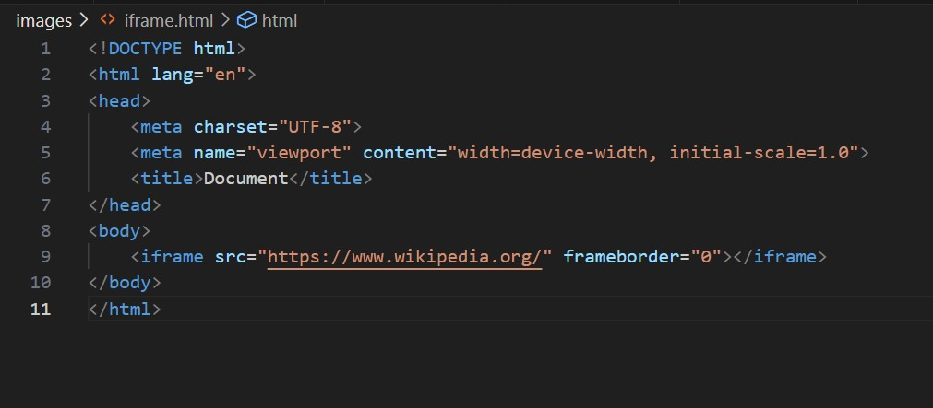

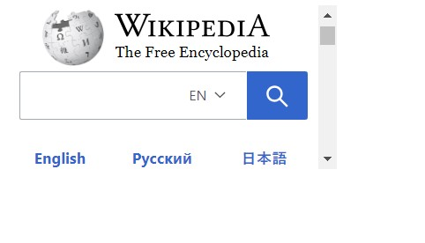

**Q 14}What is the use of a span tag? Explain with example?**

Ans: Span tag is a inline tag. That takes only that space which they need. Span text is used to give the particular text color.

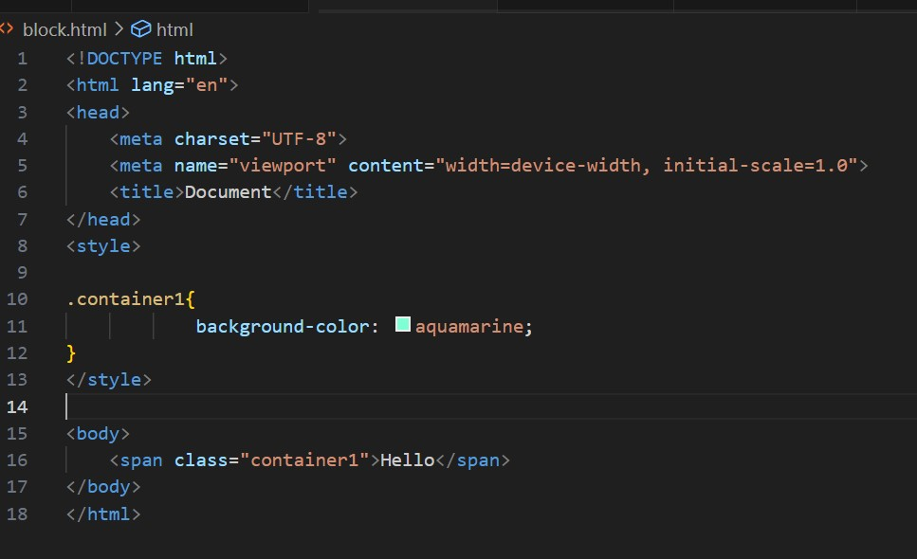

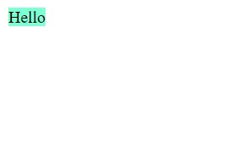

**Q 15} How to insert a picture into a background image of a web page? With Example**

**Ans :-** to add background image is using the background image attribute inside the <body> tag

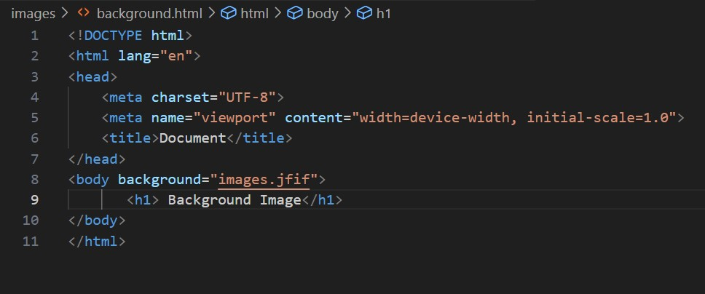

**Q 16} How are active links different from normal links?**

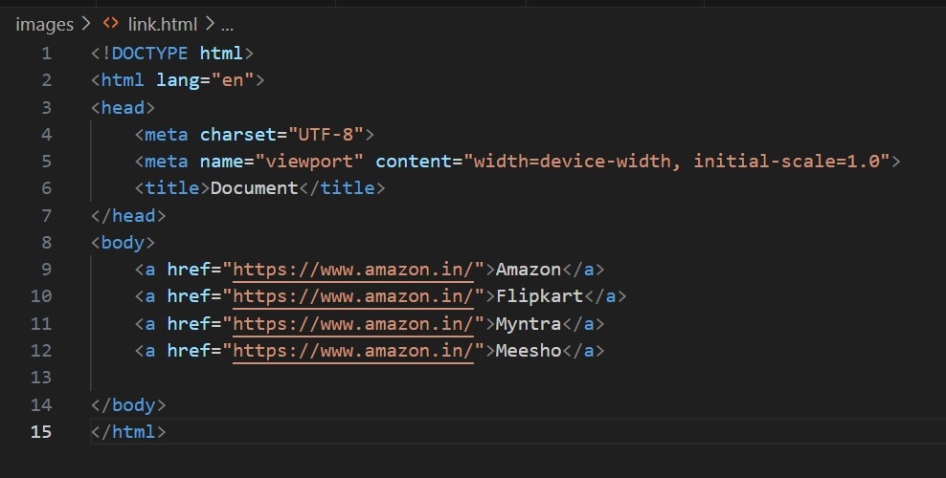



**Q 17}What are the different tags to separate sections of text?**

Ans:

There are the tags to Separate a Sections of Text

Which is- <br> Tag

<p> Tag

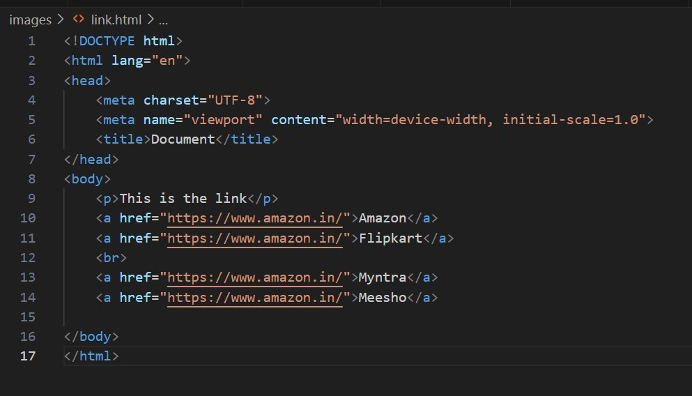

**Q 18}What is SVG?**

Ans :- SVG is a language for describing 2D graphics in XML.

**Q 19}What is the difference between HTML and XHTML?**

Ans :- XHTML is basically an extension of HTML, which is stricter than HTML.

**Q 20}What are logical and physical tags in HTML?**

**Ans :-** Physical tag: These tags are used to provide the visual appearance to the text

Logical tag: These tags are used to add some logical or semantic value to the text.